Sofia University
Department of Mathematics and Informatics
Course : OO Programming with C#.NET
Student Name:
Lab No. 1a

Submit the all C# .NET files developed to solve the problems listed below. Use comments and Modified-Hungarian notation.
Problem No. 1
Build the GUIs given in each part of this exercise. (You need not provide any functionality.) Execute each program, and determine what happens when a control is clicked with the mouse. Drag controls from the Toolbox onto the form and resize them as necessary.

- This GUI consists of a MainMenu and a RichTextBox. After inserting the Main- Menu, add items by clicking the Type Here section, typing a menu name and pressing Enter. Resize the RichTextBox to fill the form.

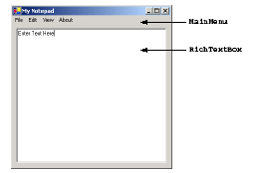

- This GUI consists of two Labels (12-point font size, yellow background), a Month- Calendar and a RichTextBox. The calendar is displayed when the MonthCalendar is dragged onto the form. [Hint: Use the BackColor property to change the background color of the labels.]

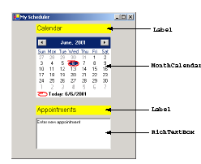
- Create the GUI for the calculator as shown below
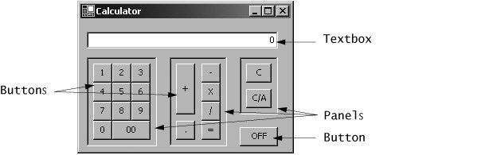.
- Manipulating the Form's properties. Change the Size property of the Form to 272, 192. Change the Text property of the Form to Calculator.
- Adding a TextBox to the Form. Set the TextBox's Text property in the Properties window to 0. Change the Size property to 240, 20. Set the TextAlign property to Right; this right aligns text displayed in the TextBox. Finally, set the TextBox's Location property to 8, 16.
- Adding the first Panel to the Form. Panel controls are used to group other controls. Change the Panel's BorderStyle property to Fixed3D to make the inside of the Panel appear recessed. Change the Size property to 88, 108. Finally, set the Location property to 8, 48. This Panel contains the calculator's numeric keys.
- Adding the second Panel to the Form. Change the Panel's BorderStyle property to Fixed3D. Change the Size property to 72, 108. Finally, set the Location property to 112, 48. This Panel contains the calculator's operator keys.
- Adding the third (and last) Panel to the Form. Change the Panel's BorderStyle property to Fixed3D. Change the Size property to 48, 72. Finally, set the Location property to 200, 48. This Panel contains the calculator's C (clear) and C/A (clear all) keys.
- Adding Buttons to the Form. There are 20 Buttons on the calculator. Add a Button to the Panel by dragging and dropping it on the Panel. Change the Text property of each Button to the calculator key it represents. The value you enter in the Text property will appear on the face of the Button. Finally, resize the Buttons, using their Size properties. The Buttons labeled 09, x, /, -, = and . should have a size of 24, 24. The 00 and OFF Buttons are sized 48, 24. The + Button is sized 24, 64. The C (clear) and C/A (clear all) Buttons are sized 32, 24.
- (Alarm Clock GUI) Create the GUI for the alarm clock as shown below
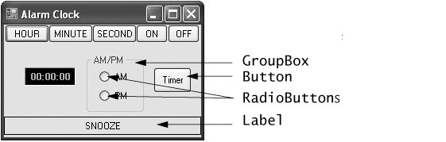
- Manipulating the Form's properties. Change the Size property of the Form to 256, 176. Change the Form's Text property to Alarm Clock.
- Adding Buttons to the Form. Add six Buttons to the Form. Change the Text property of each Button to the appropriate text. Change the Size properties of the Hour, Minute and Second Buttons to 56, 23. The ON and OFF Buttons are sized 40, 23. The Timer Button is sized 48, 32. Align the Buttons as shown.
- Adding a Label to the Form. Add a Label to the Form. Change the Text property to Snooze and set the AutoSize property to False. Set its Size to 248, 23. Set the Label's TextAlign property to MiddleCenter. Finally, to draw a border around the edge of the Snooze Label, change the BorderStyle property of the Snooze Label to FixedSingle.
- Adding a GroupBox to the Form. GroupBoxes are like Panels, except that GroupBoxes can display a title. Change the Text property to AM/PM, and set the Size property to 72, 72. To place the GroupBox in the correct location on the Form, set the Location property to 104, 38.
- Adding AM/PM RadioButtons to the GroupBox. Change the Text property of one RadioButton to AM and the other to PM, then set the AutoSize property of each RadioButton to False. Then place the RadioButtons as shown by setting the Location of the AM RadioButton to 16, 16 and that of the PM RadioButton to 16, 40. Set their Size properties to 48, 24.
- Adding the time Label to the Form. Add a Label to the Form and change its Text property to 00:00:00. Change the BorderStyle property to Fixed3D and the BackColor to Black. Set the AutoSize property to False, then set the Size property to 64, 23. Use the Font property to make the time bold. Change the ForeColor to Silver (located in the Web tab) to make the time stand out against the black background. Set TextAlign to MiddleCenter to center the text in the Label. Position the Label as shown.
Problem No. 2
Implement the method Find-median. The function find-median accepts three irregular values as formal parameters and returns the median of the three numbers. The median of three numbers is the number that is greater than one of the numbers and less than the other number. The median of 10, 30 and 20 is 20. The median of 5, 5 and 5 is 5. The median of 12, 20 and 12 is 12. A call to find-median will take the form:

median = Find-median(num1,num2,num3);
Problem No. 3
A company wants to transmit data over the telephone, but they are concerned that their phones may be tapped. All their data is transmitted as four-digit Integers. They have asked you to write a program that encrypts their data so that it may be transmitted more securely. Your program should read a four-digit Integer entered by the user and encrypt it as follows: Replace each digit by (the sum of that digit plus 7) modulo 10. Then swap the first digit with the third, and swap the second digit with the fourth. Print the encrypted Integer. Write a method that inputs an encrypted four-digit Integer and another method that decrypts it to form the original number.

